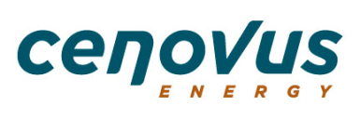
Declaration of Conflict of Interest Form

Pursuant to the Code of Business Conduct & Ethics and Conflicts of Interest Standard

Employee/Contractor Name: Click here to enter text.

Declaration Date: Click here to enter text.

Supervisor/Cenovus representative name: Click here to enter text.
I, Click here to enter text., hereby declare the following actual, potential or perceived conflict of interest:
1. Name of company(ies) or individual(s) involved with the actual, potential or perceived conflict of interest including Cenovus’s and your relationship with the companies or individuals and your role in relation to the companies or individuals:
Click here to enter text.
2. Detailed description of the actual, potential or perceived conflict of interest:
Click here to enter text.
3. After discussions with my Cenovus supervisor or Cenovus representative, we have agreed that the following actions will be taken and monitored to mitigate the actual, potential or perceived conflict of interest (see the Conflict of Interest Mitigation Examples for guidance):
Click here to enter text.

I, Click here to enter text., hereby confirm that the information in this form is true and accurate to the best of my knowledge and agree to be subject to the actions noted to mitigate the actual, potential or perceived conflict of interest. I also understand that I will not disclose any Cenovus internal or confidential information to the named company(ies) or individual(s), nor will I use my position or influence contrary to the Conflicts of Interest Standard.
If there is a change to circumstances related to the conflict noted above, or if the information disclosed in this form requires revision, I agree to prepare and resubmit a revised form.
If you have any questions, please contact Enterprise.Compliance@cenovus.com.

Please send the completed form to Enterprise.Compliance@cenovus.com and copy your supervisor or Cenovus representative.

